OSI Model Self-Study Guide

1. Introduction
Computer networks move data between devices across cables, radio links, routers, and servers. Because this process is complex, engineers use the OSI model (Open Systems Interconnection) as a conceptual framework to describe how network communication works in seven ordered layers.
This guide is a self-study document to:
- Explain the role of each OSI layer.
- Give example protocols, APIs, and libraries for each layer.
- Understand POSIX/BSD sockets as programming interfaces to the transport layer.
- Use load balancing at Layer 4 and Layer 7 as a practical case that makes the layered model concrete.

2. OSI model overview
The OSI model splits network communication into seven layers, from the Physical layer at the bottom to the Application layer at the top. Each layer has a specific responsibility and interacts mainly with the layer above and below it.
A simple way to remember the structure:
- Layers 1–3: focus on moving bits and packets through the network.
- Layers 4–7: focus on end-to-end communication and what the data means to applications and users.
List of the seven layers (from bottom to top):
- Physical
- Data Link
- Network
- Transport
- Session
- Presentation
- Application
Often we deal interchangeably between TCP/IP and OSI Model as shown below.
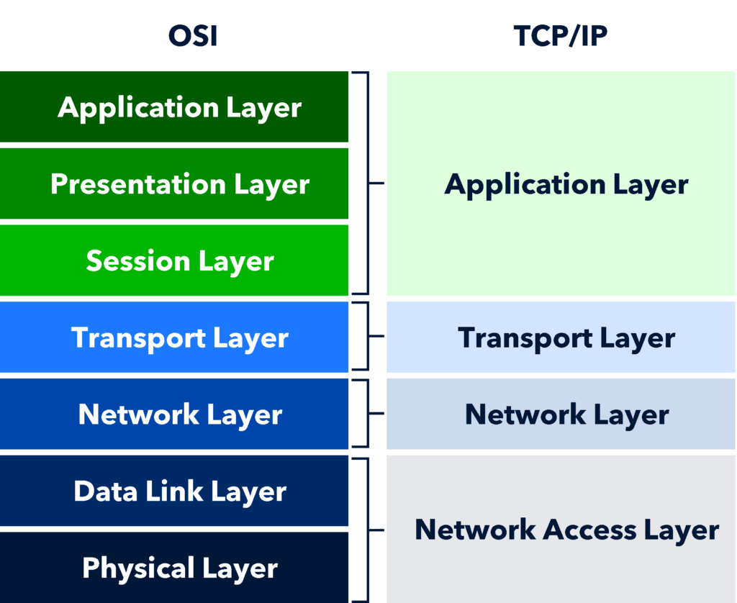

3. The seven layers in detail

3.1 Layer 1 – Physical
Role:
The Physical layer is responsible for transmitting raw bits over the physical medium, such as copper cables, fiber optics, or radio waves. It defines characteristics like voltage levels, timing, connectors, and physical topology.
Examples:
- Copper twisted-pair Ethernet cables.
- Fiber optic links.
- Wi-Fi radio signals and antennas.
- Network interface card (NIC) physical connectors.
When troubleshooting, questions like “Is the cable connected?”, “Is there a signal?”, or “Is the link light on?” are Layer 1 concerns.

3.2 Layer 2 – Data Link
Role:
The Data Link layer provides reliable local delivery on a single link or local area network (LAN). It packages data into frames, uses MAC addresses, and handles error detection and sometimes correction.
Example technologies and protocols:
- Ethernet (wired LAN).
- Wi-Fi MAC operations (802.11).
- PPP (Point-to-Point Protocol).
Typical components:
- Network Interface Card (NIC) drivers.
- Switches performing MAC-based forwarding.
Layer 2 answers questions such as “Which device on this local network should receive this frame?”

3.3 Layer 3 – Network
Role:
The Network layer is responsible for routing packets between different networks using logical addressing (IP addresses). It selects paths through intermediate routers so data can travel from source to destination across multiple networks.
Example protocols:
- IP (Internet Protocol).
- ICMP (Internet Control Message Protocol).
- Routing protocols like RIP, OSPF, or BGP.geeksforgeeks+1
Common tools:
- ping to test reachability.
- traceroute to see the path packets take through routers.
Layer 3 concerns include “Which route should this packet take?” and “Can I reach that IP address?”

3.4 Layer 4 – Transport
Role:
The Transport layer provides end-to-end communication between hosts, including segmentation of data, reliability, flow control, and error recovery. It ensures that data arrives complete, in order, or—depending on protocol—makes trade-offs for speed.
Example protocols:
- TCP (Transmission Control Protocol): reliable, ordered, connection-oriented.
- UDP (User Datagram Protocol): simple, connectionless, no built-in reliability.
Programming interface – POSIX/BSD sockets:
Developers rarely manipulate TCP or UDP frames directly; they use the socket API, historically defined by Berkeley (BSD) and standardized by POSIX.
Key functions include:
- socket() – create a socket endpoint.
- bind() – associate a socket with a local address and port.
- listen() – mark a socket as a passive server that can accept connections.
- accept() – accept an incoming connection on a listening socket.
- connect() – connect a client socket to a remote address.
- send() and recv() – send and receive data over a connected socket.
These APIs sit between your application and the transport protocols TCP/UDP, making Layer 4 practically accessible from code.

3.5 Layer 5 – Session
Role:
The Session layer manages and coordinates sessions (conversations) between applications. It can open, control, and close logical connections, handle checkpoints, and sometimes manage reconnection.
Examples:
- Remote Procedure Call (RPC) mechanisms.
- Session management for long-running application exchanges.
- Some authentication or login/session control systems.
While the boundaries between Session, Presentation, and Application are less strict in modern stacks, understanding the idea of “session” helps in system design.

3.6 Layer 6 – Presentation
Role:
The Presentation layer deals with data representation, including format conversion, encryption, and compression. It ensures that data sent by one system is in a format understandable by the receiving system.
Examples:
- TLS/SSL for encryption and protection.
- Data formats like JSON, XML, CSV.
- File formats like JPEG, PNG.
- Character encodings such as UTF-8.nordlayer+1
Example libraries:
- Cryptography libraries (for TLS).
- JSON/XML parsers.
- Codec libraries for images, audio, and video.
Developers interact with this layer mainly through libraries that hide the complexity of encryption and encoding.

3.7 Layer 7 – Application
Role:
The Application layer provides network services directly to user-level applications. It defines protocols that applications such as browsers, mail clients, and chat apps use.
Example protocols:
- HTTP and HTTPS (web).
- DNS (name resolution).
- SMTP, IMAP, POP3 (email).
- FTP or SFTP (file transfer).
Examples in code and tools:
- REST APIs over HTTP, used by web and mobile apps.
- Browser APIs for making web requests.
- HTTP client libraries such as Python requests or JavaScript fetch.
From a developer’s perspective, Layer 7 is often where business logic and application communication are designed.

4. Protocols, APIs, and libraries
To build networked applications, it is important to distinguish protocols, APIs, and libraries:
- A protocol defines the format, rules, and behavior on the network—for example HTTP, TCP, IP, DNS.
- An API is the programming interface your application uses to access the network stack—for example POSIX/BSD socket calls.
- A library is reusable code that uses APIs to implement higher-level features, such as an HTTP client library or TLS library.
A typical flow:
- Your application uses a library (e.g., an HTTP client).
- The library uses the socket API (POSIX/BSD) to send data.
- The socket API uses TCP/UDP (Layer 4), IP (Layer 3), Ethernet/Wi-Fi (Layer 2), and the physical medium (Layer 1).

5. POSIX and BSD sockets
Berkeley sockets (BSD sockets) are the original socket API for network and inter-process communication on Unix systems. They introduced the concept of a “socket” as an endpoint for communication that behaves similarly to a file descriptor.
POSIX is a standard that formalizes many Unix-like system interfaces, including the socket API. Modern Unix, Linux, and many other systems implement POSIX-compliant or very similar socket interfaces.
The socket API enables:
- Creation of network endpoints (socket()),
- Binding to local addresses (bind()),
- Accepting connections (listen(), accept()),
- Initiating outbound connections (connect()),
- Sending and receiving data (send(), recv()).
From an OSI perspective, these functions sit between application logic (Layer 7) and the transport protocols (Layer 4), offering a practical gateway into the network stack from code.

6. Data flow through the OSI layers
When a user accesses a website, the data travels through the OSI layers as follows:
- Application layer (7): The browser creates an HTTP request for a specific URL.
- Presentation layer (6): If HTTPS is used, TLS encrypts the data; data might be encoded using JSON or other formats.
- Session layer (5): Session mechanisms may handle login state or persistent connections.
- Transport layer (4): The HTTP data is segmented and carried by TCP, providing reliability and ordered delivery.
- Network layer (3): TCP segments are wrapped in IP packets with source and destination IP addresses.
- Data Link layer (2): IP packets are framed into Ethernet or Wi-Fi frames, using MAC addresses for local delivery.
- Physical layer (1): Frames are converted into electrical signals or radio waves and transmitted across the medium.
On the receiving side, this process is reversed—signals become bits, bits become frames, frames become packets, packets become transport segments, and finally the original HTTP request is reconstructed for the web server.
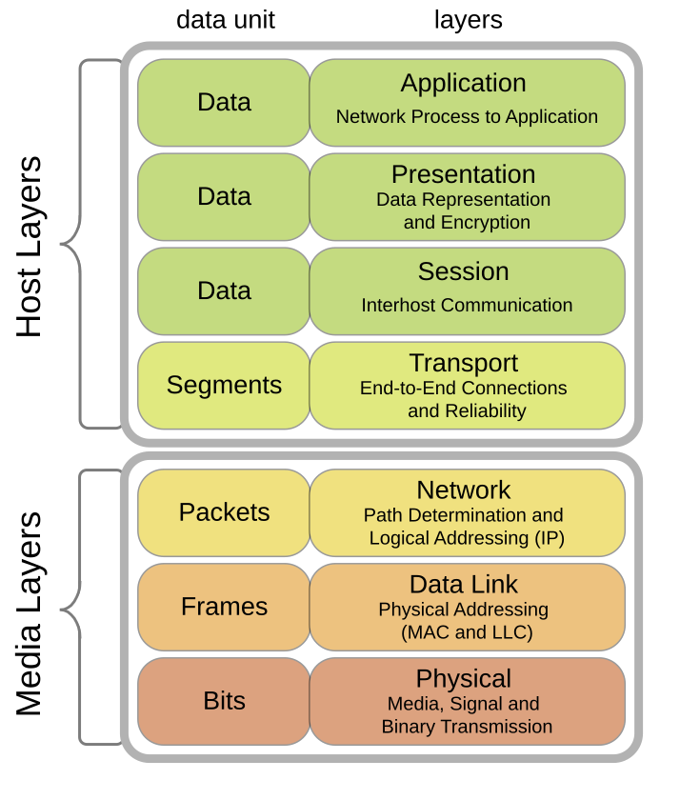

7. Load balancing as a practical OSI case
Load balancing distributes client traffic across multiple frontend or backend servers to improve performance, scalability, and availability. It is a good real-world example that shows how different OSI layers can be used for different kinds of decisions.

7.1 Layer 4 load balancing
Operating layer:
Layer 4 load balancing works at the Transport layer, using TCP/UDP information.
Decision basis:
- Source and destination IP addresses.
- Source and destination ports.
- Protocol type (TCP vs UDP).
Characteristics:
- Does not inspect application-level content (e.g., HTTP paths or headers).
- Fast and efficient, suitable for high-throughput scenarios.
- Often implemented in network appliances or cloud network load balancers.
Example scenario:
All incoming TCP connections on port 443 (HTTPS) are distributed across a pool of web servers using a round-robin or least-connections algorithm. The load balancer only cares about connections, not URLs or cookies.

7.2 Layer 7 load balancing
Operating layer:
Layer 7 load balancing works at the Application layer, understanding protocols like HTTP, gRPC, and others.
Decision basis:
- URL paths (e.g., /api/, /images/).
- HTTP headers and methods.
- Cookies and application-level metadata.
Characteristics:
- Can route different types of requests to different backend services.
- Ideal for microservices, APIs, and content-aware routing.
- Usually implemented with application-level proxies or ingress controllers.
Example scenario:
Requests with path /api/login are sent to an authentication service, while requests for /static/img are sent to a separate set of servers optimized for static content. The load balancer reads the HTTP request before deciding where to send it.

7.3 Why OSI matters for load balancing
The OSI model helps you understand:
- What information is available at each layer (e.g., ports at Layer 4, URLs at Layer 7).
- Which kind of load balancer to choose depending on whether you need speed (Layer 4) or rich application-aware decisions (Layer 7).
Thinking in layers avoids confusion and helps you design architectures that separate network-level logic from application-level logic.

